Haresh Bharadwaj – 192321037

**30) Develop wireframes for a visually rich mobile app with optimized graphics and UI performance, using Figma to showcase the design principles.**

**Aim:**

To Develop wireframes for a visually rich mobile app with optimized graphics and UI performance, using Figma to showcase the design principles.

**Procedure:**

1. Open Figma
2. Create a new file
3. Select the Frames
4. Design Visual Elements
5. Make it Interactive
6. Add icons on the Frame
7. Incorporate Multimedia
8. Storyboard Animation
9. Review and edit the Prototype
10. Save and Share

**Design:**

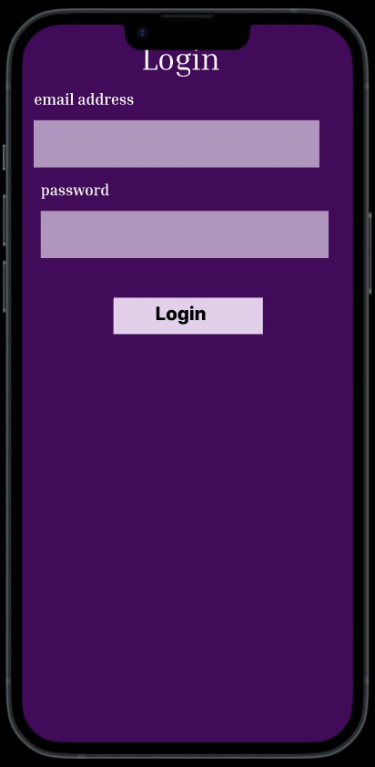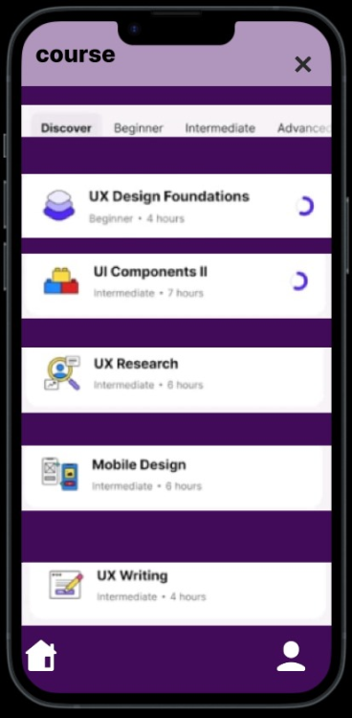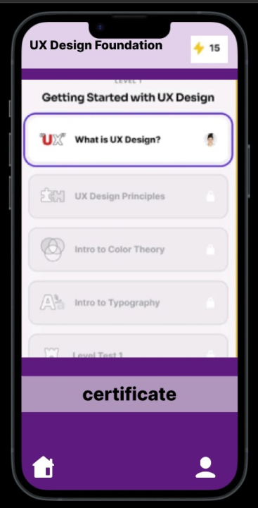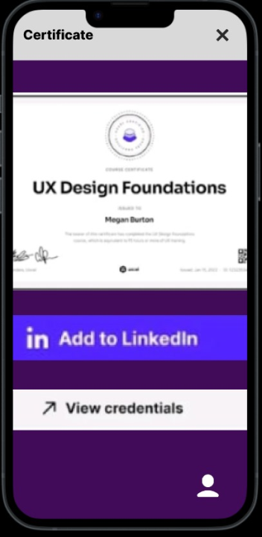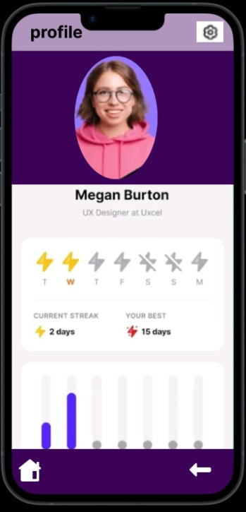

**Prototype:**

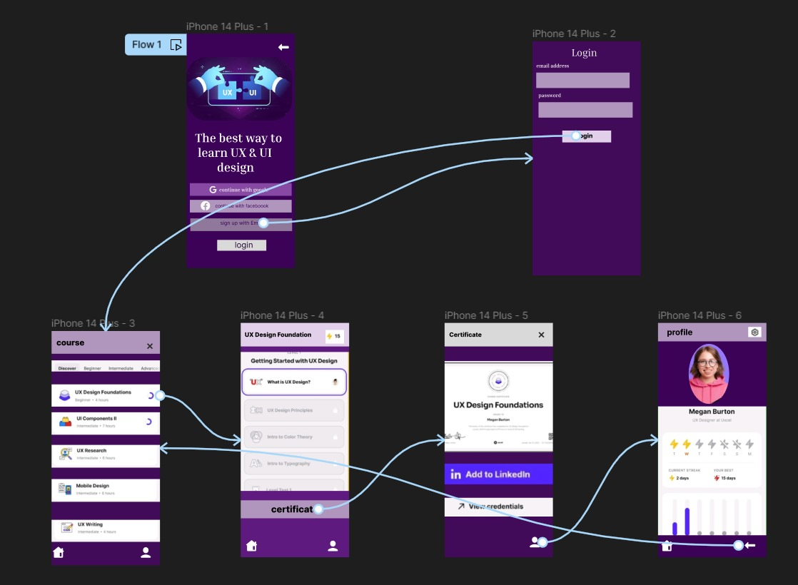

**Result:**

Thus The Develop wireframes for a visually rich mobile app with optimized graphics and UI performance is created and executed successfully.